Liz Miller

EDU 338: Curriculum Activity with SOC/EM Adjustments Lesson Plan 1 8 December 2015

Grade Level: Pre-K

Domain: Cognitive

Materials Needed:
- Wooden blocks: ramp, 2 or 3 rectangles
- Various items to roll down ramp: mini bottle; small cylinder block; small toy car; plastic Easter egg; wooden cube; wooden wheel; roll of tape; wooden triangle; craft pom-pom; etc.
- Large foam shapes: ramp; cube; sphere; triangle

Standards:
- SCI 2.4: Make predictions and generate ideas based on past experience, observations, and information.
- SED 2.1: Use words, in English and/or home language, and non-verbal communication to communicate needs, ideas, experiences, and emotions.

Objectives:
- The student will make predictions about what objects will roll down the ramp.
- After experimentation, the student will either discuss or record which items do and do not roll down the ramp and why.
- The student will work with a partner to develop communication skills and peer friendship.

Learning Activities:
- The experimenting center will be introduced with a lesson on movement. I will demonstrate by using the large foam/mat shapes.
- Throughout the demonstration, I will talk through my own predictions about what the shapes will do, all the while communicating with the class by questioning. For example, “I think the triangle will roll down the ramp faster than the square, what do you think?”
- To allow for the class’ curiosity to flourish, I will not demonstrate with the objects given but instead encourage the class to do so. If they finish with the provided objects, they will be able to find other small objects in the play area to try on the ramp.
- I will be sure to remind the students that they are to stay with their partners and work together, talk together through the experimentation.
- Encourage student to make decisions and vocalize what extra items he/she would like to roll down the ramp.

Assessment:
- The assessment will be a check-for understanding after the allotted time for all the students to rotate through the center.
- I will make sure to check in with the student to assist him/her in communicating the experiment.

Reflection:
- What did I do well?

Liz Miller EDU 338: Curriculum Activity Lesson Plan 2 8 December 2015

Grade Level: Pre-K

Domain: Cognitive

Materials Needed:
- Construction paper
- Scissors
- Markers
- 3 or 4 sets of various sizes of circle cut-outs

Standards:
- MTH 3.3: Order objects by size and length.
- SED 2.7: Work cooperatively with others and exhibit appropriate social behavior.

Objectives:
- The students will discuss largest to smallest.
- The students will work together in small groups to create a scale of largest to smallest hand and foot sizes.
- The student will engage in conversation with his/her group to sort circle and hand/foot cut-outs.

Learning Activities:
- The class will be split into their usual table groups, and the largest to smallest lesson will be introduced and demonstrated with the circle sizes.
- The students will then be directed to trace a partner’s hand and shoe, proceeding to cutting out their traces. Here, the student will be encouraged to communicate to his/her partner, building on confidence and peer friendship.
- With the teacher as only an assistant, the students will work together to try to sort hands and feet by largest to smallest.
- When all groups have finished sorting, the class will be brought together to make a group-scale of largest to smallest.

Assessment:
- Students will be assessed on participation and group skills.

Reflection:
- What did I do well?

Liz Miller EDU 338: Curriculum Activity Lesson Plan 3 8 December 2015

Grade Level: Pre-K

Domain: Cognitive

Materials Needed:
- Short cardboard roles
- Yarn
- Small decorations
- Crayons
- Pencils
- Clipboards
- “What Do You See Out the Window?” double-sided handout (see attached)

Standards:
- SCI 2.1: Use simple tools and simple machines to investigate their environment.
- SED 2.1: Use words, in English and/or home language, and non-verbal communication to communicate needs, ideas, experiences, and emotions.

Objectives:
- The students will use their hand-made binoculars to observe their environment.
- The students will work with a partner and both observe and record what is seen out the window.
- The student will be paired with an outgoing student who can set the example of verbalizing what is observed through the binoculars.
- The student will build on the skill of initiation when verbalizing observations.

Learning Activities:
- After the students have created their binoculars, the next activity will be to use their creations to look out of the classroom window to observe their environment.
- The students are given their partners and are directed to take turns observing through the window and recording the information with their partner.
- The students will come together to discuss what was observed and if they noticed anything that was not on the handout. The discussion will continue about what is natural in our environment vs. what is man-made and how each object contributes to the environment.

Assessment:
- Assessment will be on cooperation with partners and participation in the project.

Reflection:
- What did I do well?

What do you see out the window?

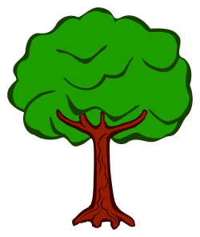

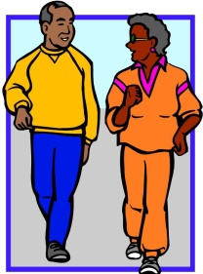

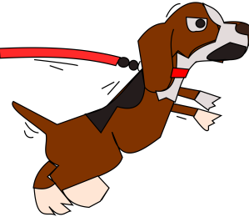

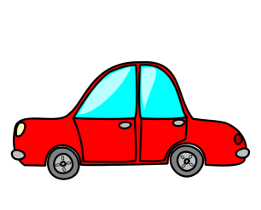
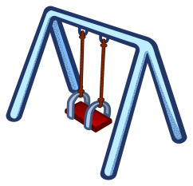

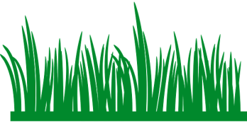

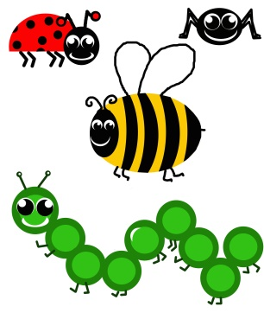

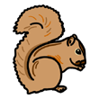

Liz Miller EDU 338: Curriculum Activity Lesson Plan 4 8 December 2015

Grade Level: Pre-K

Domain: Language

Materials Needed:
- Handout of visual of different emotions (see attached)

Standards:
- LL 5.3: Understand and use new vocabulary and descriptive language to describe feelings, thoughts, experiences, and observations.
- SED 1.3: Show increasing ability to regulate and communicate own feelings and emotions.

Objectives:
- The students will discuss how to tell what someone is feeling by looking at their face.
- In groups of 2 or 3, the students will take turns telling their partner(s) to make a specific emotion.
- The student will use words to direct the partner(s) to make desired faces/emotions.

Learning Activities:
- Discuss with the students how to know what someone is feeling by looking at their face.
- Demonstrate this by making faces and having the students guess how you might be “feeling.”
- After check-for-understanding, pair the students and hand out the visual.
- Check in with the student to assist him/her in building initiative.

Assessment:
- Students will be assessed on their ability to create the facial expression and work cooperatively with their partners.
- Assessment will be a check in with the groups of students to look for cooperation and initiative.

Reflection:
- What did I do well?

Liz Miller EDU 338: Curriculum Activity Lesson Plan 5 8 December 2015

Grade Level: Pre-K

Domain: Language

Materials Needed:
- None

Standards:
- LL 5.2: Use language for a variety of purposes.
- SED 1.7: Show self-direction, independence, and initiative.

Objectives:
- Students will listen to directions when playing the “Red Light, Yellow Light, Green Light” game.
- Student will lead one round of “R,Y, G Light” with initiative.

Learning Activities:
- Introduce the game – if there are a few students who have played before, use them as helpers to demonstrate.
- The general rules of the game are as follows: 1) one student is the street light, the remaining students are street cars; 2) the street light turns his/her back to the students and calls out “Green Light” or “Yellow Light” – GL: the students run, YL: the students walk; 3) the street light calls out “Red Light” when he/she wants to turn around, and if a street car is caught moving, the street light will call him/her out and they get to go to the “parking lot” for the rest of the round;
*4) The street light will also be required to use the street car’s name if he/she wants to send them to the parking lot;
5) the round is over when all/most of the street cars are caught.

Assessment:
- Students will be assessed on their ability to follow directions of the game and of the street light student.

Reflection:
- What did I do well?

Liz Miller EDU 338: Curriculum Activity Lesson Plan 6 8 December 2015

Grade Level: Pre-K

Domain: Language

Materials Needed:
- Colored Pencils
- About Me Puzzle (see attached)

Standards:
- LL 3.4: Use scribbles, shapes, pictures, letters, and dictation to represent thoughts and ideas.
- SED 1.1: Recognize personal abilities, characteristics, culture, and preferences.

Objectives:
- The students will complete a puzzle that portrays different parts about their life such as: favorite color, household pets, family members, favorite food, etc.
- The students will share and discuss their work with a partner.

Learning Activities:
Part One:
- Instruct the students to create a puzzle about them. Show an example of the desired outcome.
Part Two:
- Use another student and his/her project to demonstrate the story-telling. Instruct the students to ask questions about their partner’s puzzle.
- Pair the students and monitor their story-telling and questioning.

Assessment:
- To keep the project and objectives developmentally appropriate, the students will be assessed on their cooperative skills and encouraged to have an interest about their partner’s work.

Reflection:
- What did I do well?

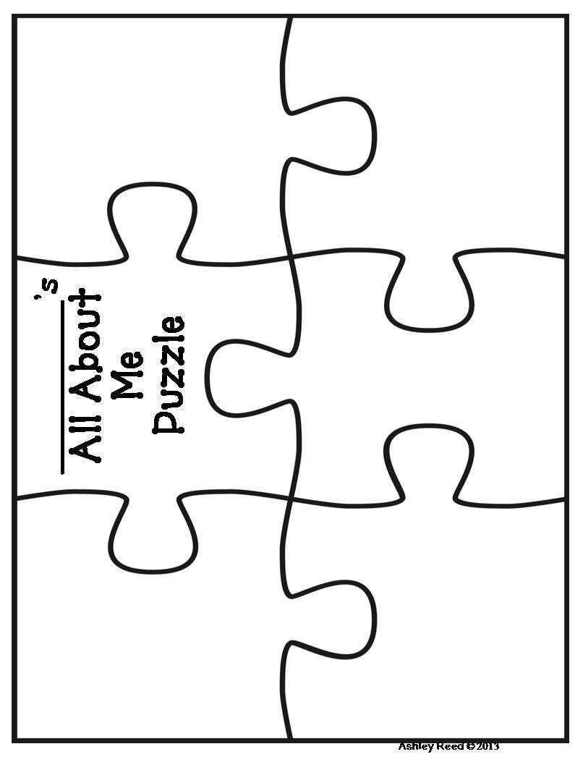
Liz Miller EDU 338: Curriculum Activity Lesson Plan 7 8 December 2015

Grade Level: Pre-K

Domain: Physical

Materials Needed:
- One Duck Stuck by Phyllis Root
- Duck & Animal Masks (see attached)

Standards:
- PD 1.1: Combine large motor movements.
- SED 2.4: Begin to develop peer friendships through group activities, tasks, and play.

Objectives:
- The students will listen to the story being read.
- The students will work together to help out the “Stuck Duck.”
- The student will build initiative and verbal skills through activity.

Learning Activities:
Who Can Help? Dramatic Play with Animal Masks
- Read One Duck Stuck to the students.
- Introduce the activity: One student will be the “Stuck Duck” while the others are different characters from the book. The Duck will have to use his/her imagination and get stuck in the mud. When this happens, he/she will call out, “Help! Help! Who can help?” The remaining characters will take turns helping pull the Stuck Duck out of the muck.
- When everyone has had the chance to switch roles, gather the students together and discuss the meaning of helping each other to “get through the muck.”

Assessment:
- This is an activity that will build peer friendships, so the goal is to scaffold and assist in this process, providing extra assistance where needed.

Reflection:
- What did I do well?

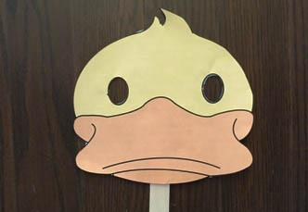

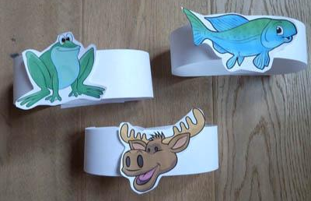

Liz Miller EDU 338: Curriculum Activity Lesson Plan 8 8 December 2015

Grade Level: Pre-K

Domain: Physical

Materials Needed:
- Large dodge balls
- Orange cones

Standards:
- PD 5.2: Work cooperatively with others in play and group physical activities.
- SED 1.4: Regulate physical actions.

Objectives:
- With a partner, the students will participate in a team relay exercise.
- The student will build peer-friendships through positive partnerships.

Learning Activities:
- Prior to the activity, place 3 or 4 cones (5 feet apart) in as many lanes as there are teams.
- Separate the students into teams and then pair them into partners. *Pair the student with a positive friend.
- Instruct the students to pass the ball back and forth between the cones, down the lane and back so that the next pair can try.
- Be sure to remind students that they are to use their words and take their time!

Assessment:
- Students will be assessed on how well they can cooperate with their given partner. Any struggles will be noted.
- Students’ large-motor movements will be assessed and observed.

Reflection:
- What did I do well?

Liz Miller EDU 338: Curriculum Activity Lesson Plan 9 8 December 2015

Grade Level: Pre-K

Domain: Physical

Materials Needed:
- Large white paper
- Large paint brushes
- Paint and paint materials

Standards:
- PD 4.2: Exhibit control, strength, and dexterity in hand muscles.
- SED 1.5: Demonstrate self-confidence in own abilities.

Objectives:
- With assistance from the teacher, students will work together in a large group to create scenery for the dramatic play center.
- The student will build peer friendships through collaboration and initiative in his/her contribution to the creation.

Learning Activities:
- Gather the students around the large, blank paper canvas and take a class vote about which scenes should be displayed in the dramatic play center.
- Explain to the students what “scenery” is and why it is important for stories and play.
- Instruct the students that they are going to help make the background for three different scenes.
- Divide the students into groups and encourage each student to contribute at least one object to the scene.
- Scaffold the students and remind them of the proper way to hold a large brush, if needed.

Assessment:
- When necessary, students will be assessed on the way to work and build dexterity.
- Group work and attitude will be observed and noted.

Reflection:
- What did I do well?

Liz Miller EDU 338: Curriculum Activity Lesson Plan 10 8 December 2015

Grade Level: Pre-K

Domain: Creative/Sensory

Materials Needed:
- Large plastic dollhouse (e.g., Fisher Price; see attached)
- Plastic tub or sensory table to place “burning house” in
- Shaving cream
- “Fire” food-coloring (red, yellow, orange) watered-down and in large bottles.
- Spray bottles for plain water
- Clean-up supplies

Standards:
- APL 2.2: Approach tasks with imagination and inventiveness.
- SED 2.7: Work cooperatively with others and exhibit appropriate social behavior.

Objectives:
- Students will use the sensory activity to support dramatic play and develop language skills.
- The student will build peer friendship through positive and fun interactions.

Learning Activities:
Firefighter Sensory Play
- Introduce the new firefighter sensory center by discussing the subject of heroes with the students.
- Instruct the students on how to play: 1) Spray the house with shaving cream; 2) Color the fire; 3) Call the firefighters! (this step means to bring in the spray bottles); 4) Put out the fire.

Assessment:
- With this activity, students will be free to work cooperatively with each other and use their imagination and the center will be open for teacher assistance and observation.

Reflection:
- What did I do well?

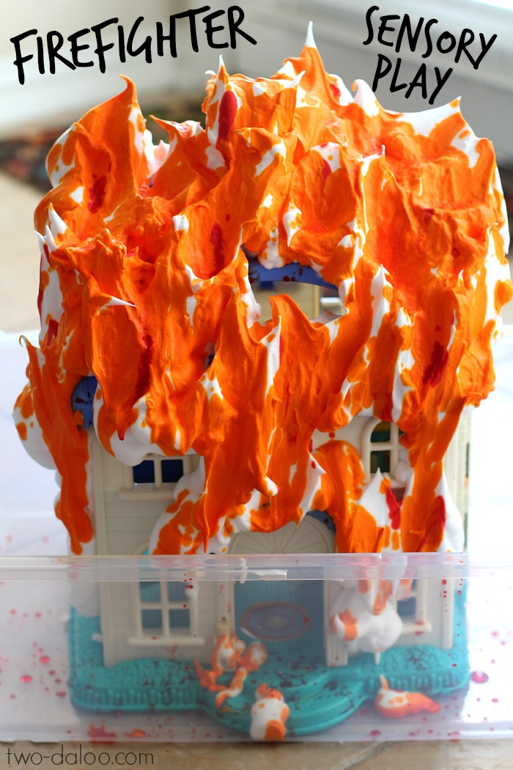

Liz Miller EDU 338: Curriculum Activity Lesson Plan 11 8 December 2015

Grade Level: Pre-K

Domain: Creative/Sensory

Materials Needed:
- Classroom instruments appropriate for a marching band.

Standards:
- ART 1.1: Coordinate movements in response to beat or rhythm in music.
- SD 2.4: Begin to develop per friendships through group activities, tasks, and play.

Objectives:
- Students will participate in a marching band.

Learning Activities:
- Introduce the activity by discussing a marching band.
- The teacher will use the drum to keep a beat.
- Have the students practice marching in place.
- Split the students into 2 small groups.
- *The student will lead a group marching around the room.
- The marching will last for a couple rounds of students leading.
- Gather the students together to talk about how it felt to be in a marching band.

Assessment:
- The students will be assessed on their ability to work together and follow the leader.

Reflection:
- What did I do well?

Liz Miller EDU 338: Curriculum Activity Lesson Plan 12 8 December 2015

Grade Level: Pre-K

Domain: Creative/Sensory

Materials Needed:
- Classroom appropriate watercolor paper
- Watercolor paint
- Watercolor paintbrushes

Standards:
- ART 4.3: Share and discuss own art work with others, including opinions, likes, and dislikes about artistic creations.
- SED 2.1: Use words, in English and/or home language, and non-verbal communication to communicate needs, ideas, experiences, and emotions.

Objectives:
- The students will explore with water colors.

Learning Activities:
- Demonstrate to the students that there are different kinds of ways to use and explore with water colors.
- Instruct the students to experiment with the different ways to use water colors: more water and less paint; more paint and less water; water on the paper and adding paint.
- After projects have been dried, have the students share their end product with another student.

Assessment:
- The students’ exploration will be observed.
- The students will be assessed on how they share and discuss their end product.

Reflection:
- What did I do well?

Liz Miller EDU 338: Curriculum Activity Lesson Plan 13 8 December 2015

Grade Level: Pre-K

Domain: Cultural Awareness

Materials Needed:
- What materials and human resources are needed?

Standards:
- What local, state, and/or national standards are covered in this lesson?

Objectives:
- How will students demonstrate the knowledge, skills, or attitudes addressed?

Learning Activities:
- How will I create and maintain student interest?

Assessment:
- How will I know students have met the targeted objectives and standards?

Reflection:
- What did I do well?

Liz Miller EDU 338: Curriculum Activity Lesson Plan 14 8 December 2015

Grade Level: Pre-K

Domain: Cultural Awareness

Materials Needed:
- What materials and human resources are needed?

Standards:
- What local, state, and/or national standards are covered in this lesson?

Objectives:
- How will students demonstrate the knowledge, skills, or attitudes addressed?

Learning Activities:
- How will I create and maintain student interest?

Assessment:
- How will I know students have met the targeted objectives and standards?

Reflection:
- What did I do well?

Liz Miller EDU 338: Curriculum Activity Lesson Plan 15 8 December 2015

Grade Level: Pre-K

Domain: Cultural Awareness

Materials Needed:
- What materials and human resources are needed?

Standards:
- What local, state, and/or national standards are covered in this lesson?

Objectives:
- How will students demonstrate the knowledge, skills, or attitudes addressed?

Learning Activities:
- How will I create and maintain student interest?

Assessment:
- How will I know students have met the targeted objectives and standards?

Reflection:
- What did I do well?

