Liz Miller – 6 November 2014 – EDU 320
Grade Level: Kindergarten/1st Grade
Subject Area: Health and English Language Arts: Reading
Materials Needed:

Teacher
- It’s a Book both by Lane Smith
- “Parts of a Book” founded on www.littlekidlibrarian.blogspot.com - attached
- Blank book, stapled
- “Book puzzle” pieces
Student
- Their individual “Book Box”
- Scissors
- Glue

Standards:
Reading
- RI.5: Identify the front cover, back cover, and title page of a book.
- RI.6: Name the author and illustrator of a text and define the role of each in presenting the ideas or information in a text.
Health
- K.1.2: Locate basic parts of the human body.

Objectives:
The students will:
- participate in a classroom discussion about the different parts of a book
- compare the spine of a book to the spine on their bodies
- at the end of the unit, create their own book, both from previously printed text as an introductory project, and then from text created on their own
Prior knowledge:
- Students will already know the expectations during carpet time and will have had previous experience of Turn & Talk.
- Students will know how to use scissors somewhat properly, as well as gluing “only around the outside.”

Learning Activities:
- Read aloud It’s a Book.
- Discuss with the students the purpose of a book, and why we love books!
- To check for prior knowledge, I will show the “Parts of a Book” (see attached) on the ActiveBoard. Students will help me fill in what they already know.
- For what we have left blank, I would use indirect instruction to discuss with the students what may be the possibilities. For example, I can foresee the Kindergarten students not knowing the following: Barcode, Spine, Illustration, and Call Number. The questions could go like this:
- Barcode: “Now, these are the three spots we have left. Which of these looks like it could be the barcode?” If a student guesses wrong, I would ask another, “Jimmy, what do you think of that?”
- Spine: “Boys and girls, if you know what your spine is, point to it on your body…” I could point which students have it right or have Turn & Talk so that they can share with their partner where they think their spine is.
- *Health* When talking about the spine, I would include a short lesson about what the spine does for our body (for example, it keeps our body together). What would happen if we did not have our spine?
“Now, let’s pretend our body is like a book and open your arms...We have our front cover, our back cover…where might the spine of the book be?”
- I will ask the students to grab one book from their Book Box and bring it to the carpet with them. While sitting in a circle, I will ask them to point to the different parts of the book.
- Since it is ideal that this activity be part of a “Book Structure” unit, and I will at this point introduce the activity: They will be creating their very own book!
- We will talk about what it means to be an author, and brainstorm ideas for our books. I will scaffold and direct the conversation toward writing about their Kindergarten school year.
- I will send the students to their work spot, and ask them to get out their glue and scissors. Their project then will be to put together a “book puzzle.” We will use a blank paper book, and I will have the different pieces that the students will cut out and paste onto the book.
Assessment:
The teacher will collect their book puzzle and determine if the individual student understood the concept of book structure and craft according to the attached rubric/checklist. The students will be assessed on their ability to place the parts of a book in correct order on their book puzzle (i.e., Title, Author, Front Cover, Back Cover, Illustration, Pages). The teacher also be observing different students periodically to assess if they are cooperating well with others and focusing their attention on the task at hand. During Daily 5, the teacher will assess each student in the group to see if he or she can point to their spine on the body. The formative assessments are marked and underlined in red. Lastly, the students will receive a copy of the attached summative assessment. They will follow the instructions given by the teacher. Before beginning this, though, the teacher will use the “3 – 2 – 1” method to check for the need to reteach.
Reflection: In what ways can I improve? In what ways was I successful?
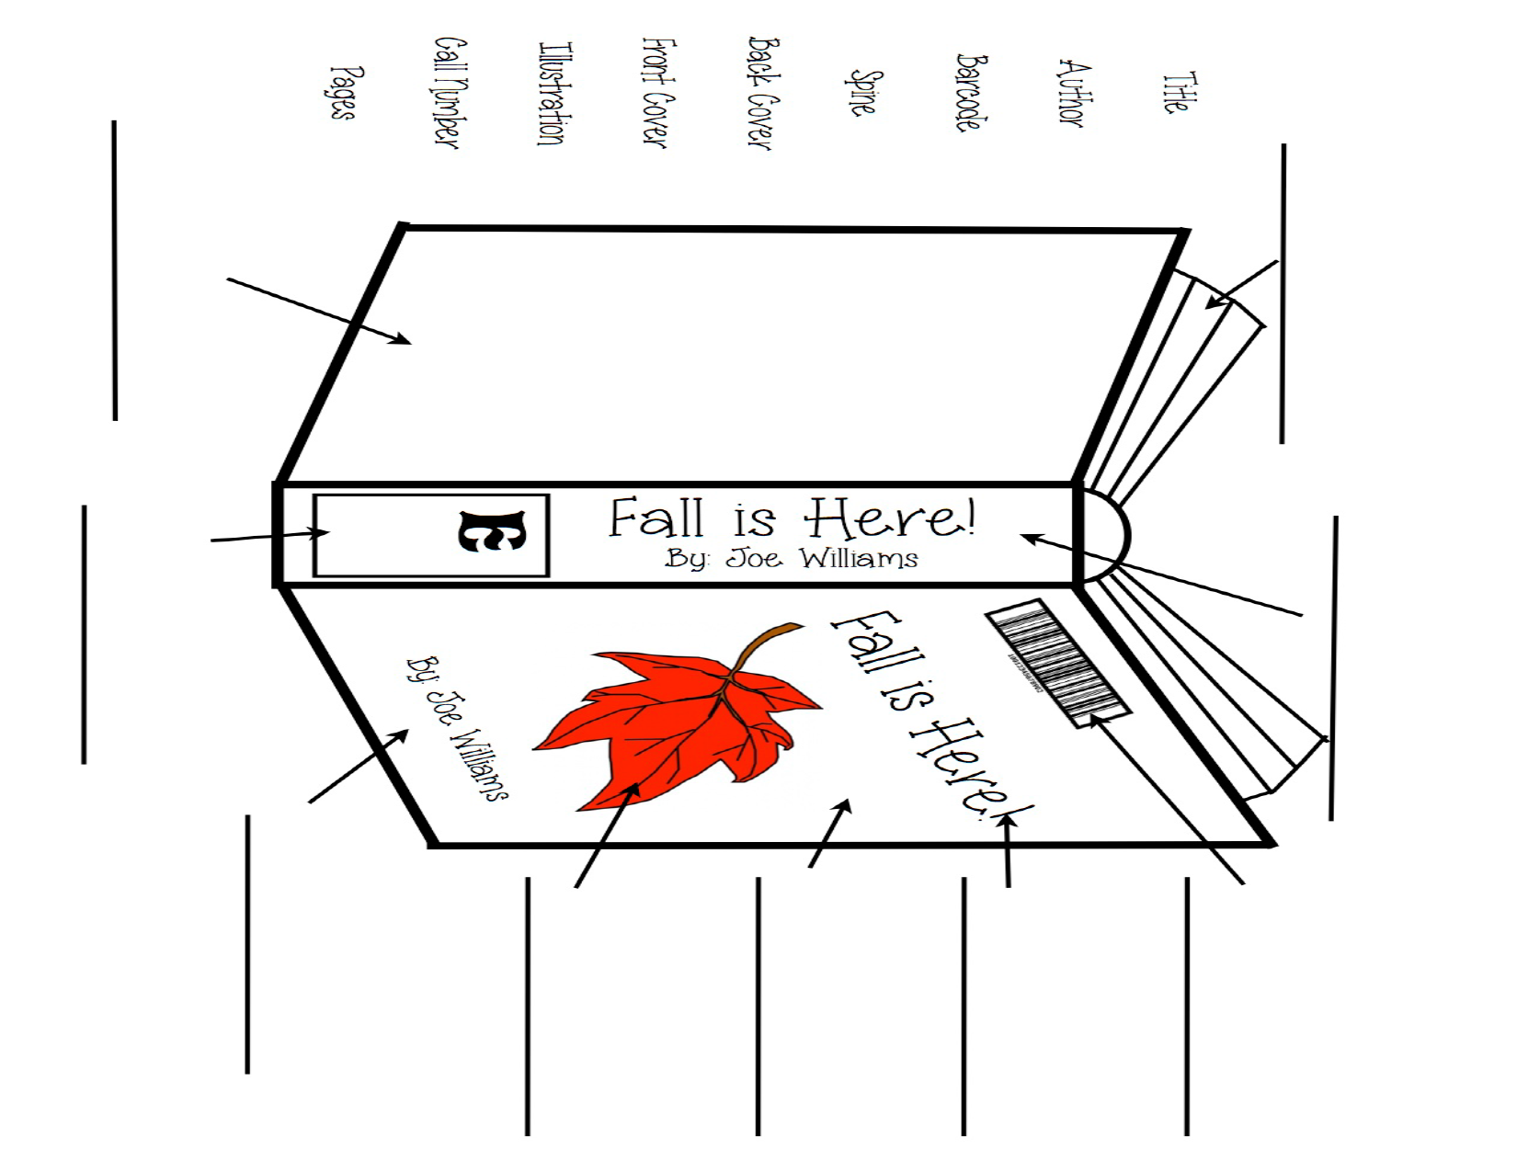
Parts of a Book Rubric
According to Standard RI.5 Name: ________________________

Objectives | Exemplary (4 points) | Above Proficient (3 points) | Proficient (2 points) | Novice (1 points)
Appropriate Book Structure and Craft (see Book Puzzle Checklist) | The student correctly labeled all 5 parts of the book. | The student labeled 4 parts of the book. | The student correctly labeled 3 parts of the book. | The student correctly labeled 2 or less parts of the book.
Demonstrating Neatness | The student cut the book parts along the lines and pastes them in an orderly fashion. | The student cut by and around the lines and pastes the pieces on in a semi-orderly fashion. | The student cut and pastes the parts of the book with fair order. | The student took little to no time cutting out the book parts and pastes them carelessly.
Cooperating with Others | The student cooperated well with others and exceeded expectations by showing kindness and helpfulness. | The student has little to no difficulty working well with others and is able to work independently without disrupting others. | The student worked well with half of the class and was slightly distracted during work time. | The student has difficulty working well with others and independently.
Focusing Attention | The student excelled at focusing attention to the task at hand and contributed to class discussion. | The student followed the instructions and contributed once to class discussion. The student had little to no distractions. | The student needed only one or two reminders about focusing attention on the task at hand. | The student needed a constant reminder to focus attention on the task at hand and was distracting to others.

Book Puzzle Checklist Name: ________________________
Front Cover
Back Cover
Title Page
Illustration
Pages

Summative Assessment
According to Standard RI.5
- Put a red circle around the title
- Put an orange square around the author
- Color the spine yellow
- Color the front cover blue
- Color the back cover purple
- Color the barcode green
- Shade the pages gray

Summative Assessment Checklist Name:____________________

Task (1 point each) | “1” = present; “X” = not present
- Put a red circle around the title

- Put an orange square around the author

- Color the spine yellow

- Color the front cover blue

- Color the back cover purple

- Color the barcode green
- Shade the pages gray

Score:

Name: _______________________

